Biomaterials and Regenerative Medicine Laboratory
The goal of the biomaterials and regenerative medicine laboratory of Semnan University is to develop biomaterial strategies that orchestrate successful tissue regeneration. Ongoing research in biomaterials lab focuses on interdisciplinary biomaterials research for a variety of tissue engineering and drug delivery applications.
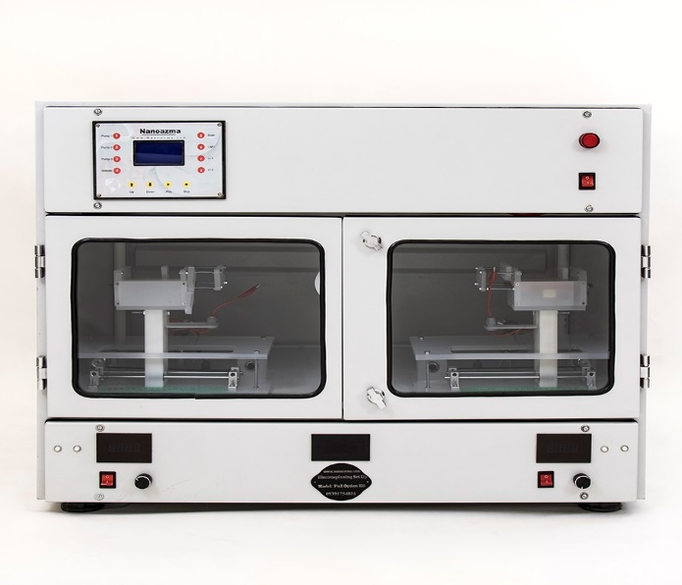
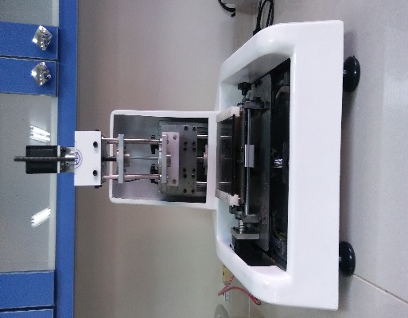

Our laboratory research focus areas:
• Functional biomaterials. Our lab develops biocompatible, biodegradable polymer and composite biomaterials, nanomaterials and hydrogels for various applications.
• Scaffolds fabrication. We are fabricating scaffolds mainly using electrospinning and 3D printing techniques for skin, bone, vessel, and cornea tissue engineering and wound dressing.
• Controlled drug delivery. Another area of interest in our lab is establishment of carriers for the controlled delivery of various bioactive molecules.

Titles of Completed Projects:
- Co-delivery of minocycline and paclitaxel from injectable hydrogel for treatment of spinal cord injury, Semnan university in collaboration with Royan institute
- Evaluation of superparamagnetic and biocompatible properties of mesoporous silica coated cobalt ferrite nanoparticles synthesized via microwave modified Pechini method, Semnan University,
- Electrospun polycaprolactone/gelatin/bioactive glass nanoscaffold for bone tissue engineering, Semnan University, Esfahan University
- Assessment of the Efficacy of Tributylammonium Alginate Surface-Modified Polyurethane as an Antibacterial Elastomeric Wound Dressing for both Noninfected and Infected Full-Thickness Wounds, Semnan university in collaboration with Royan institute
- Fabrication and Characterization of Electrospun Scaffold Based on Polycaprolactone-Aloe vera and Polyvinyl Alcohol for Skin Tissue Engineering, Semnan Universitya

